**Pre-Post Condition**

**Pre-Condition:**

The condition which needs to executed before the execution of actual steps are called as Pre-Conditions.

We can add Pre-Conditions in two ways

1.Script Level

2.Module Level

**Steps to add Pre-Condition to the Script:**

Click on Test Dev

Click on the Test script under the Module

Click on Settings

Click on +Pre-Condition

All the Step groups will be displayed (Only step groups can be added as Pre/Post condition)

Select the required Step group as Pre condition

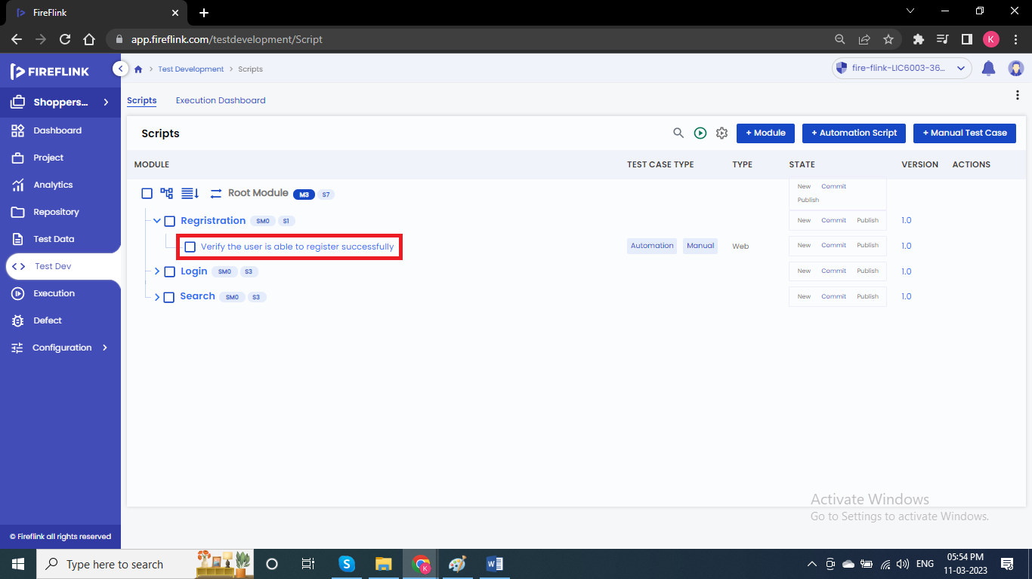

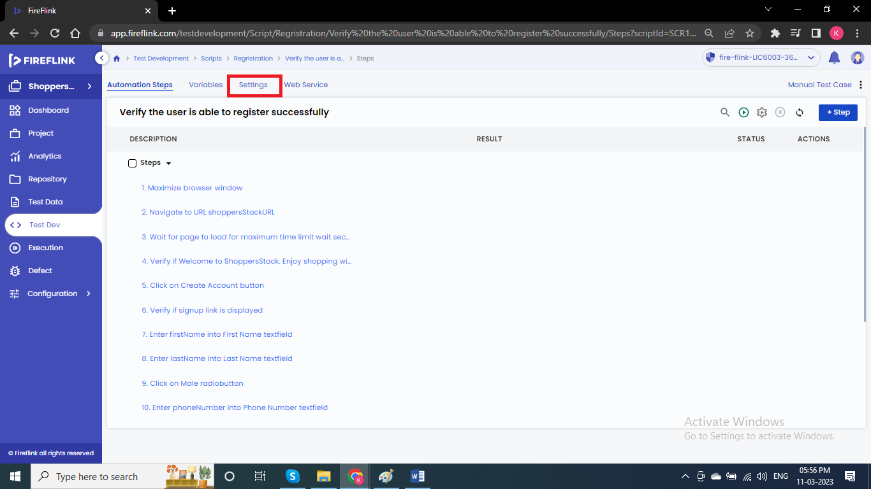

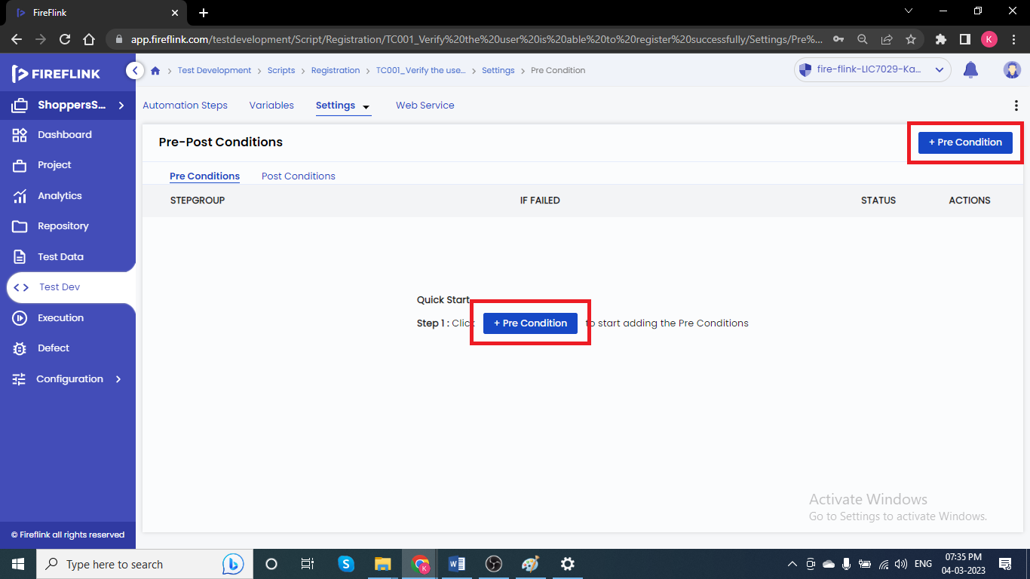

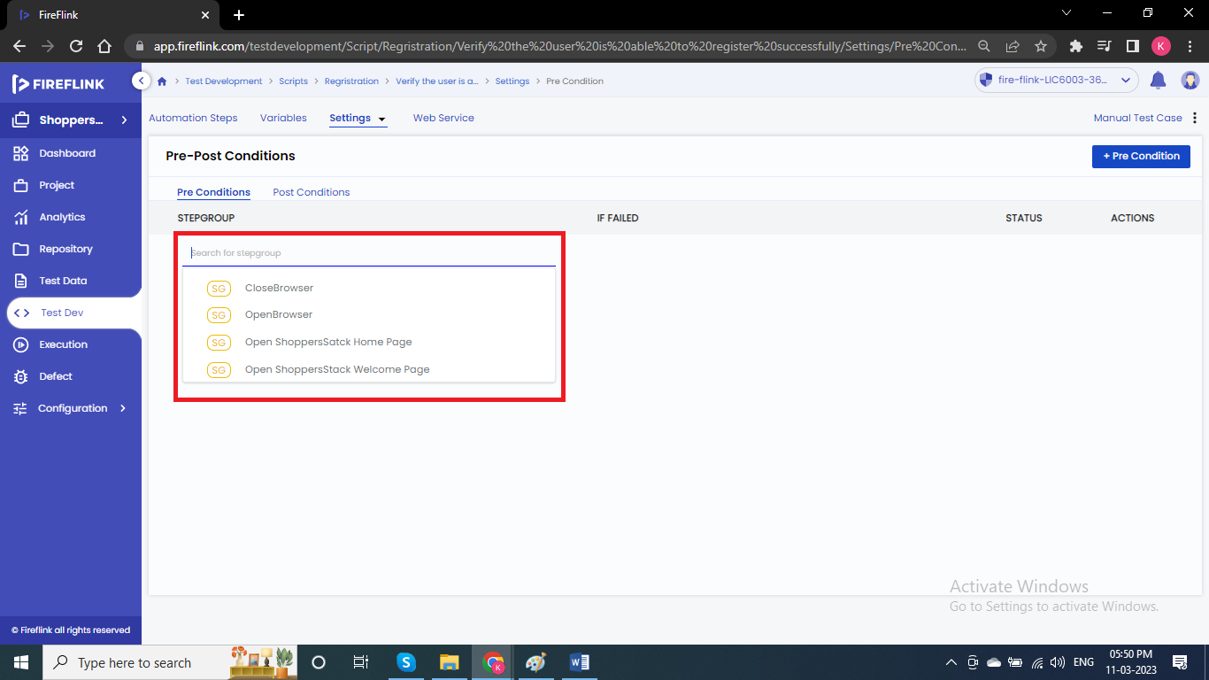

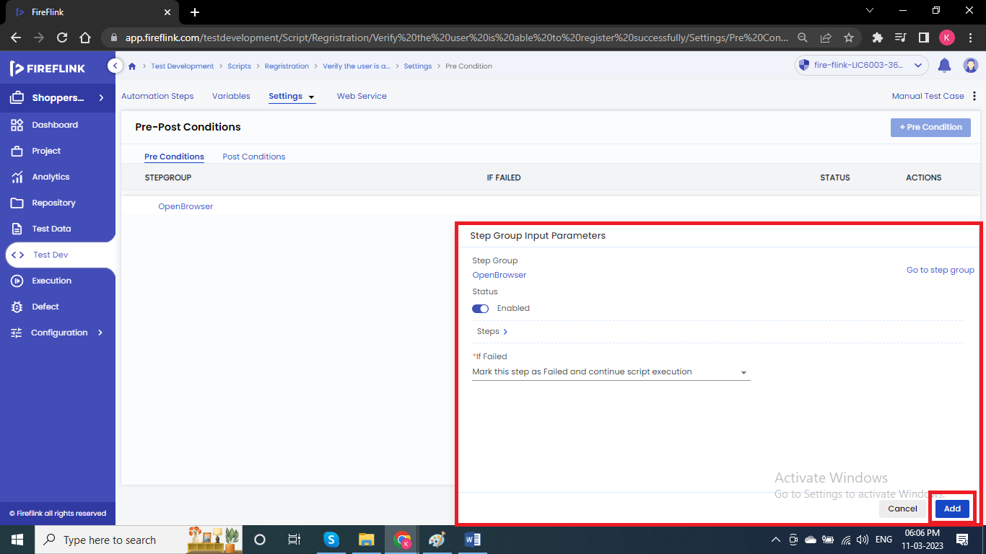

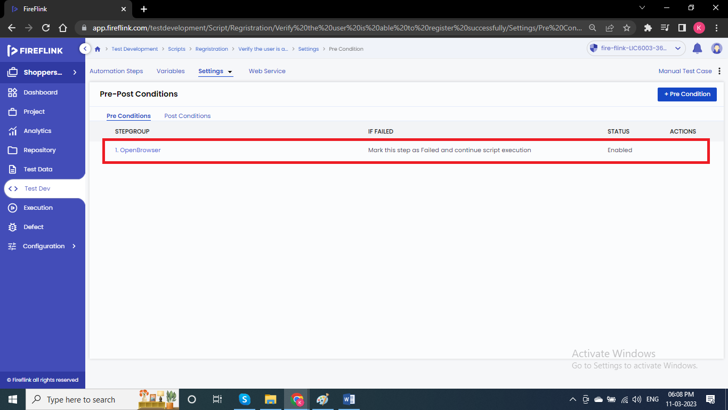

**Steps to add Pre-Condition to the Module level:**

Click on Test Dev

Click on Module

Settings

Click on +Pre-Condition

All the Step groups will be displayed

Select from them

Step Group Input Parameters popup will be displayed

Click on Add button.

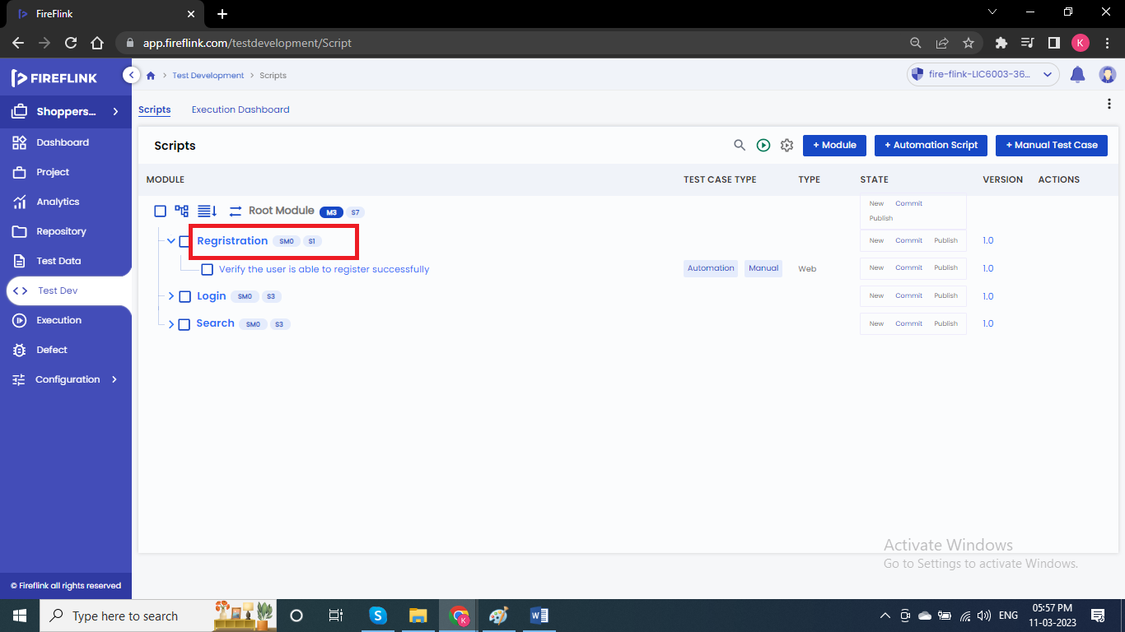

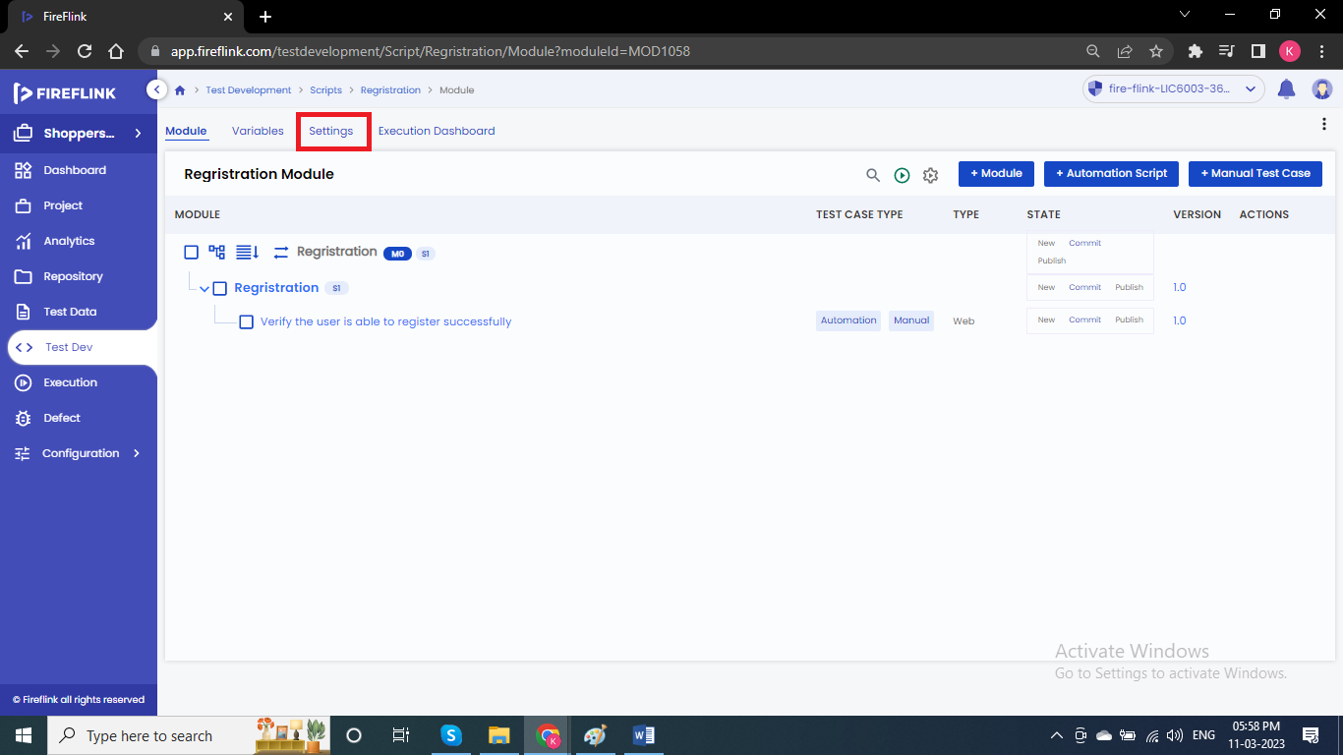

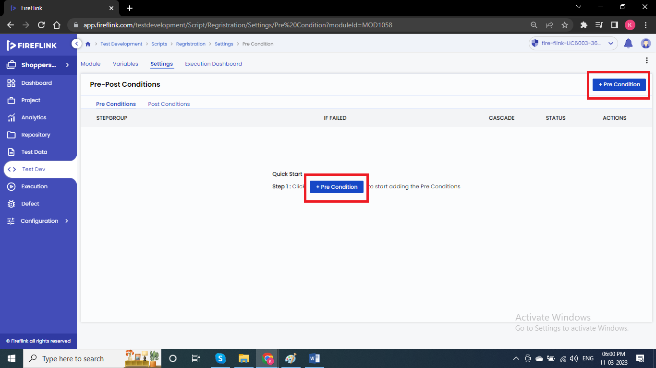

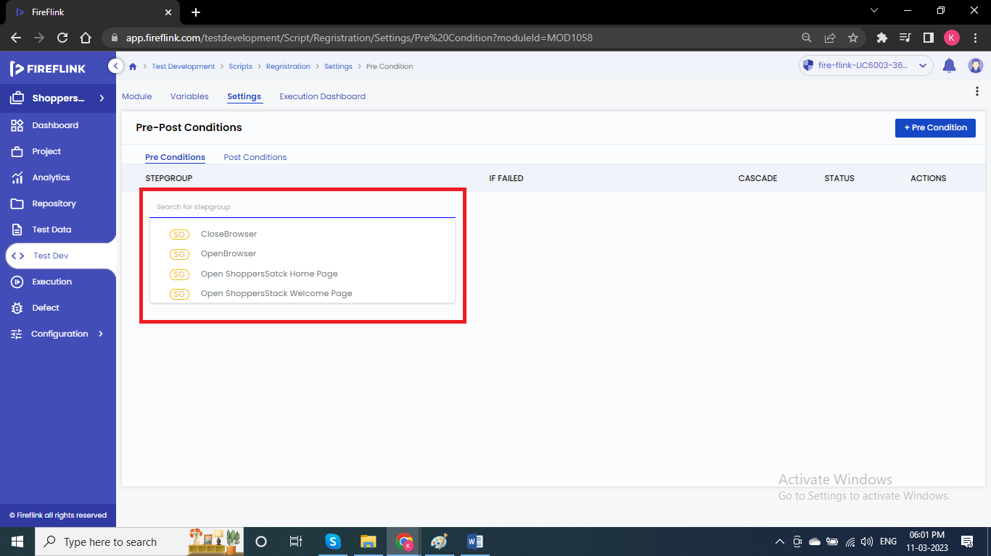

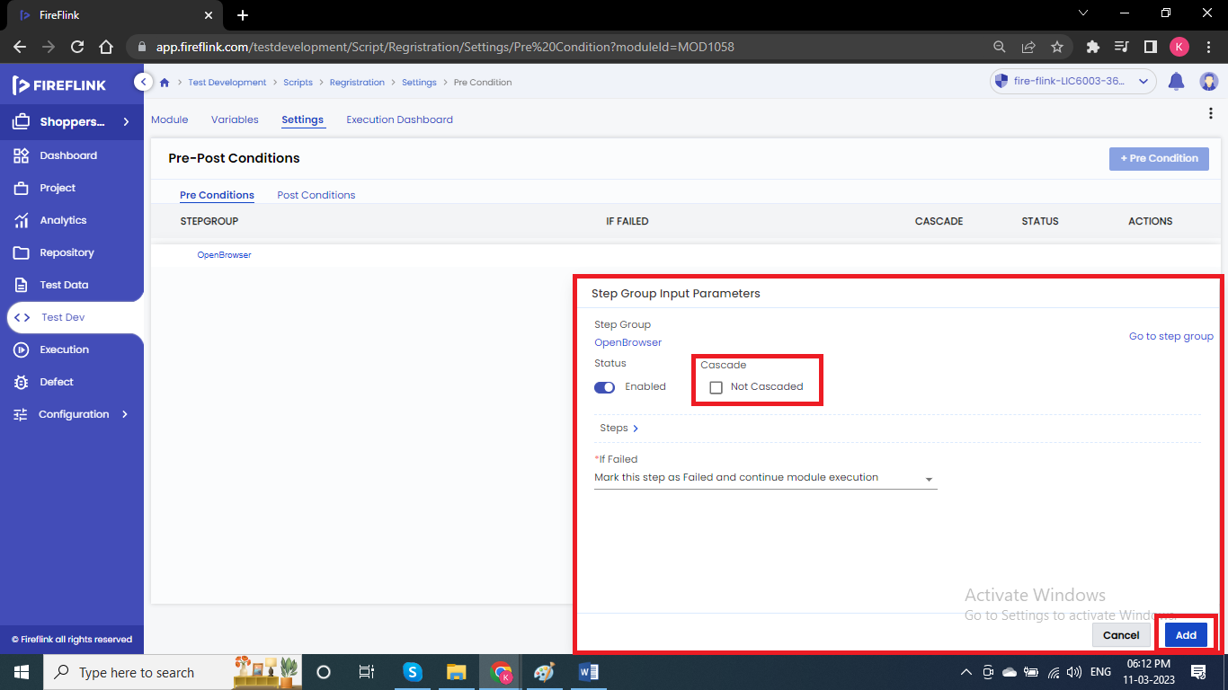

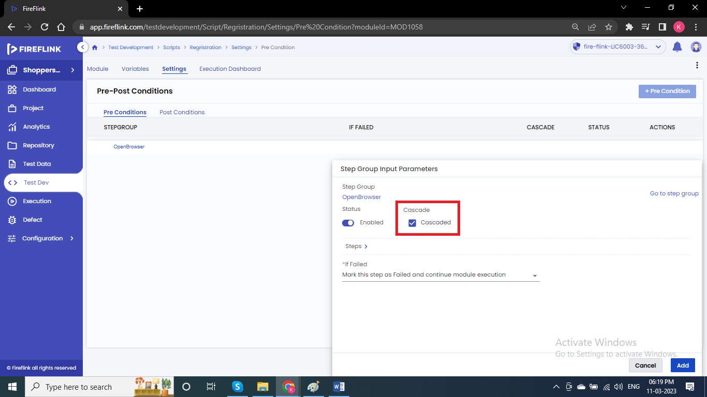

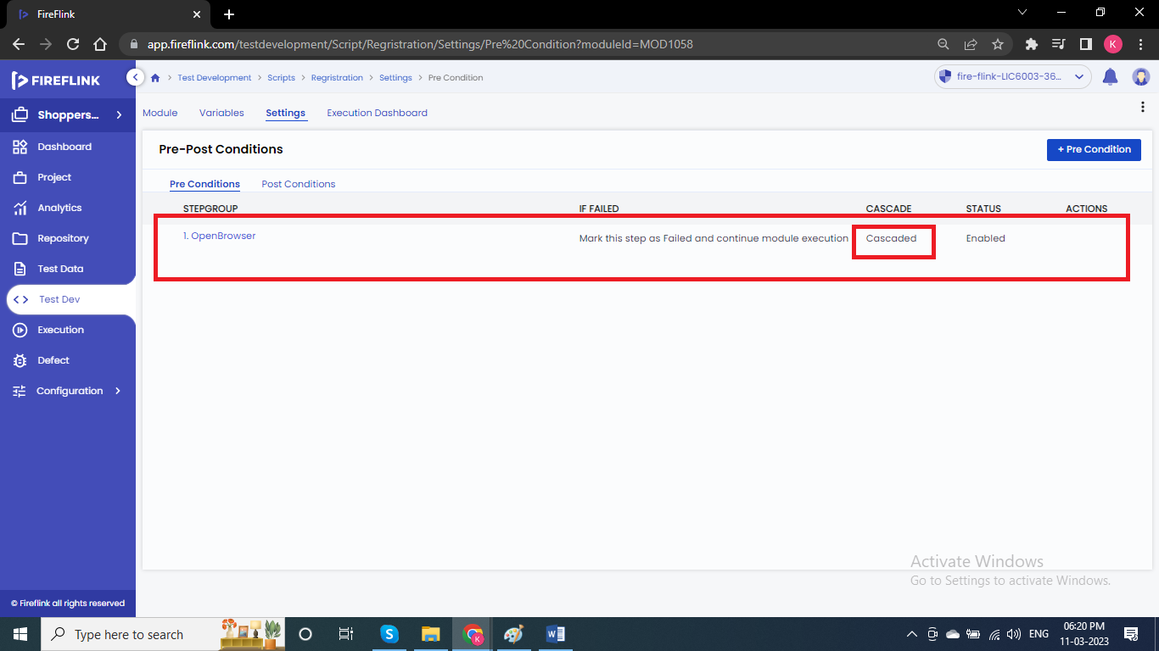

**Note:** In Module level, we have option called Cascade (Pre-condition added in module level will be applicable for all the test scripts added under that module).

**Post-Condition:**

The condition which needs to executed after the execution of actual steps are called as Post-Conditions.

We can add Post-Conditions in two ways

1.Script Level

2.Module Level

**Steps to add Post-Condition to the Scripts:**

Click on Test Dev

Click on the Test script under the Module

Click on Settings

Click on +Post-Condition

All the Step groups will be displayed

Select the required Step group as Post condition





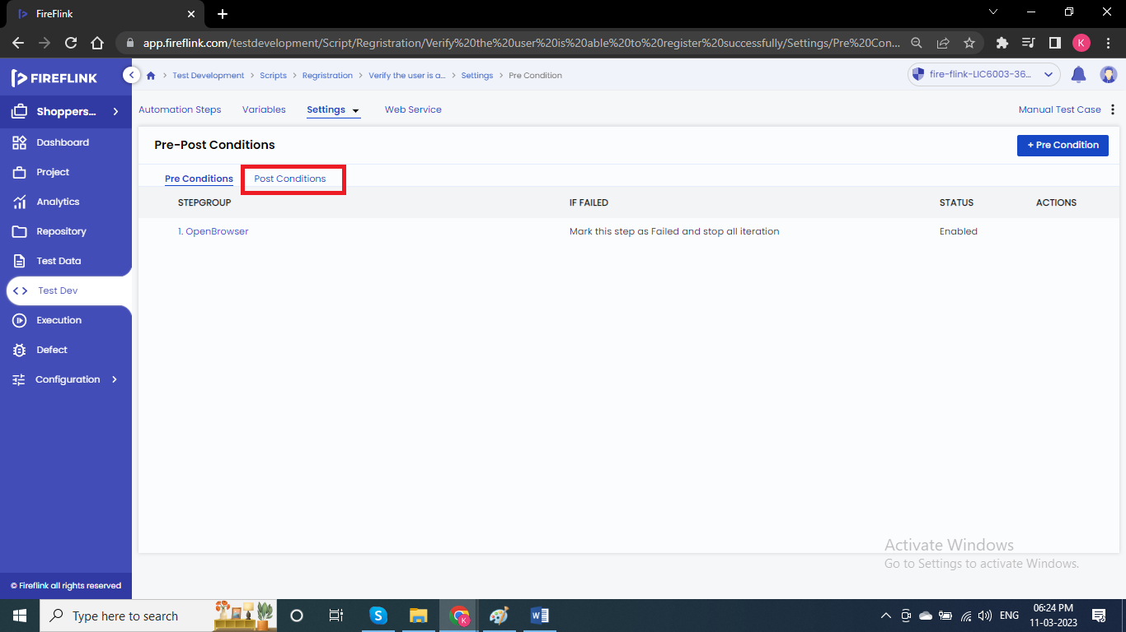

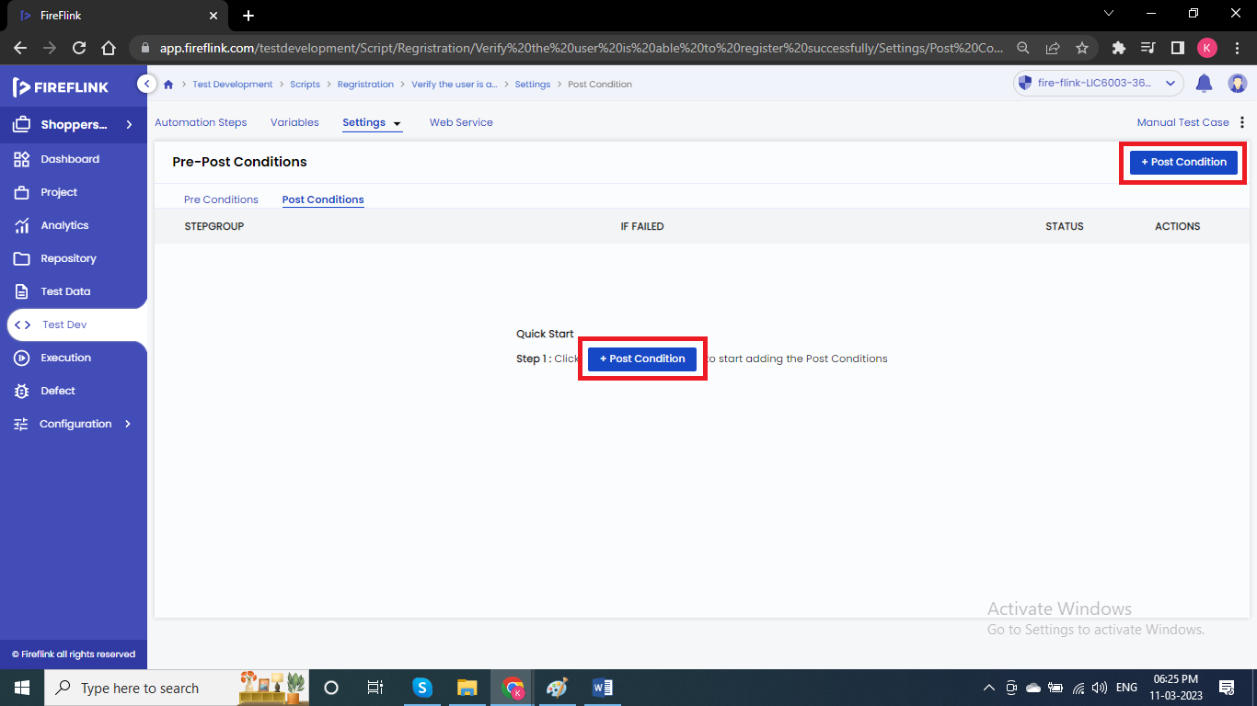

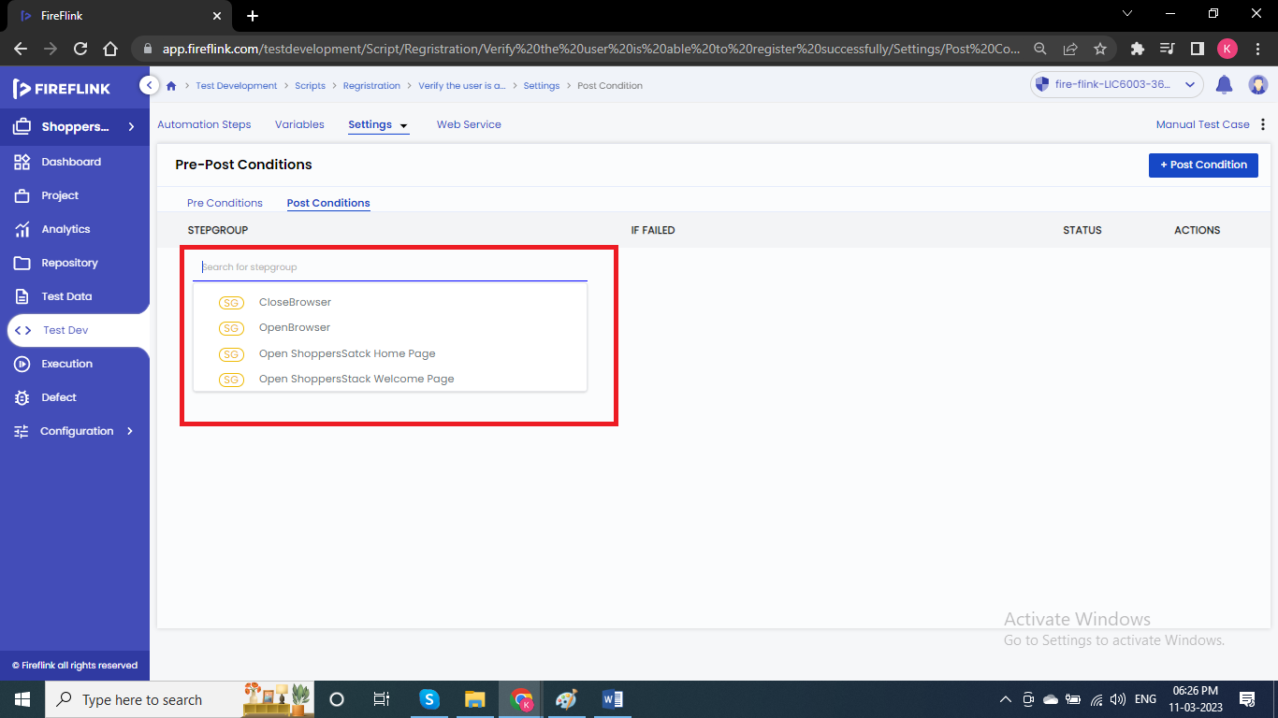

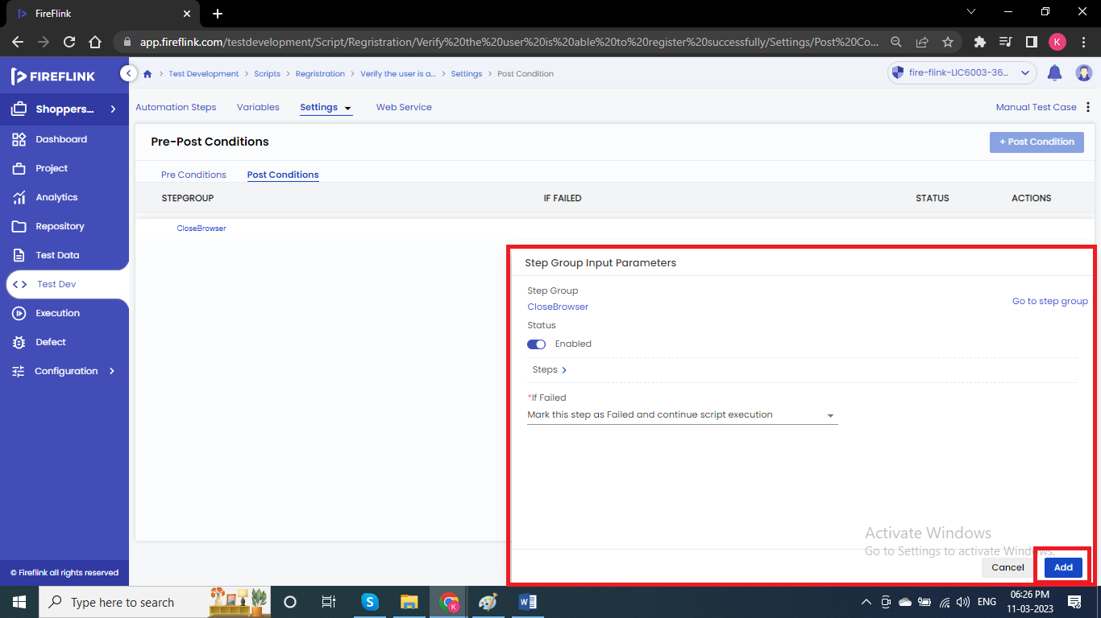

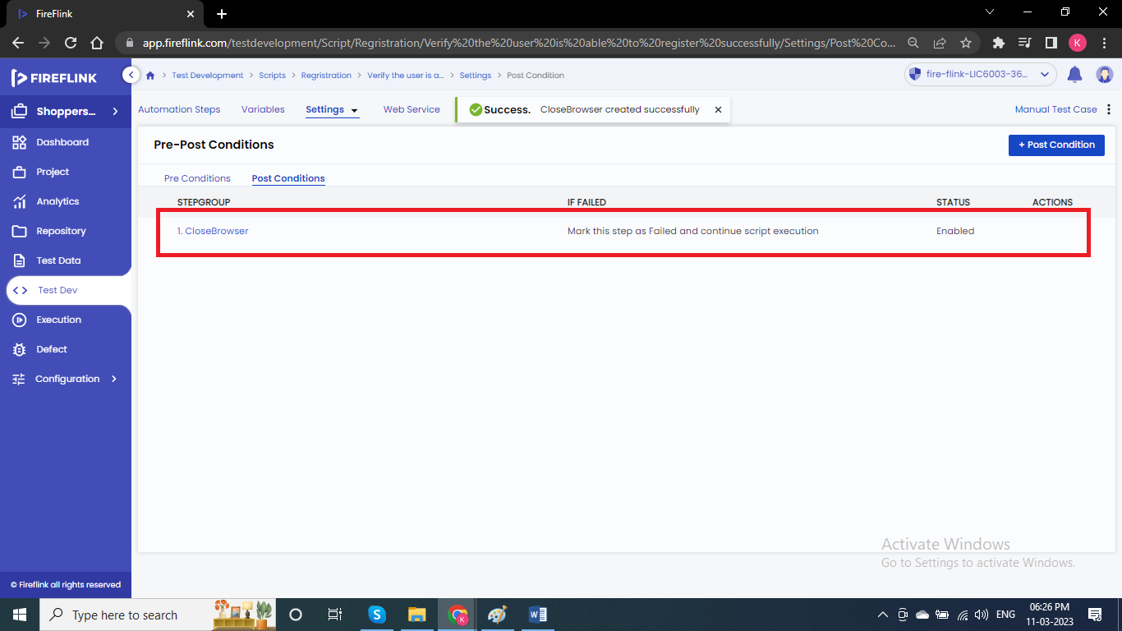

**Steps to add Pre-Condition before the Project:**

Launch the application once and execute all other steps and close.

Click on Test Dev

Click on Module

Settings

Click on +Pre-Condition

All the Step groups will be displayed

Select from them

Step Group Input Parameters popup will be displayed

Click on Add button.





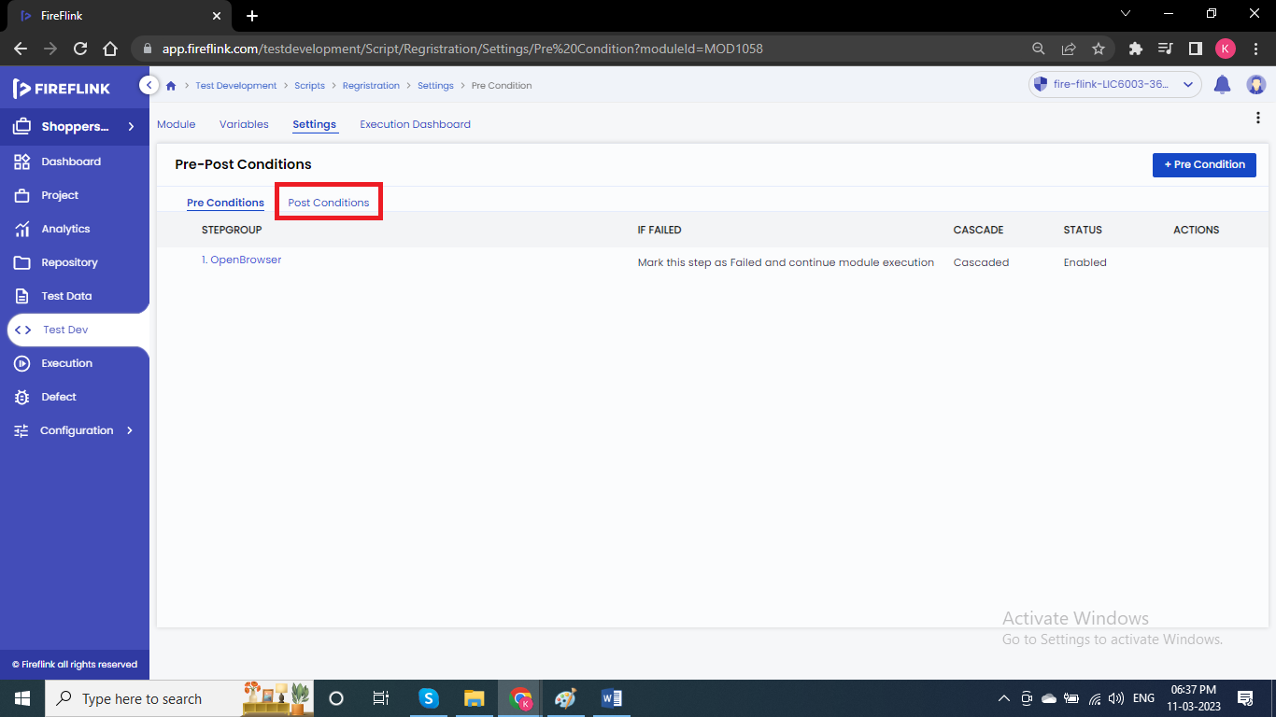

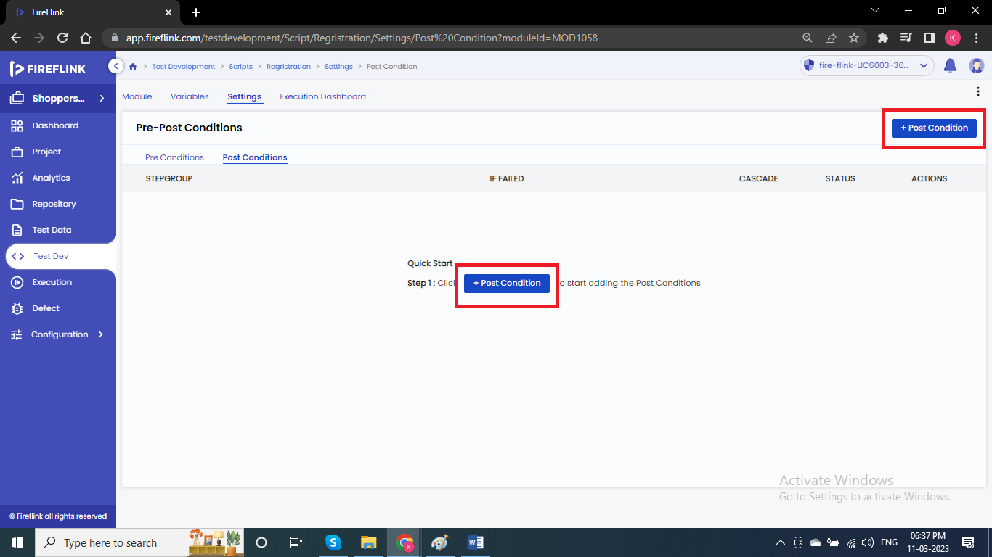

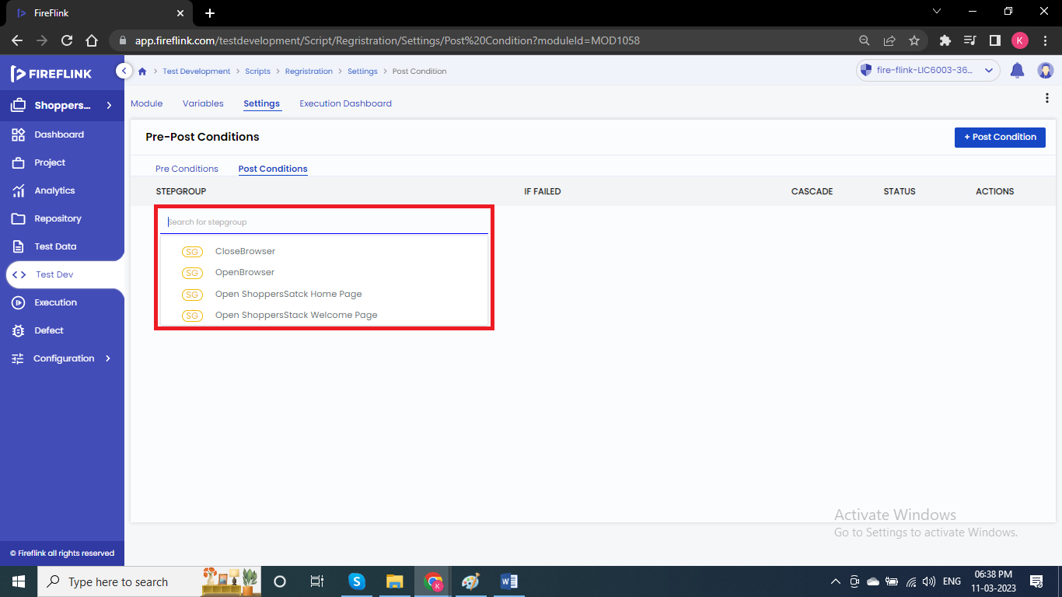

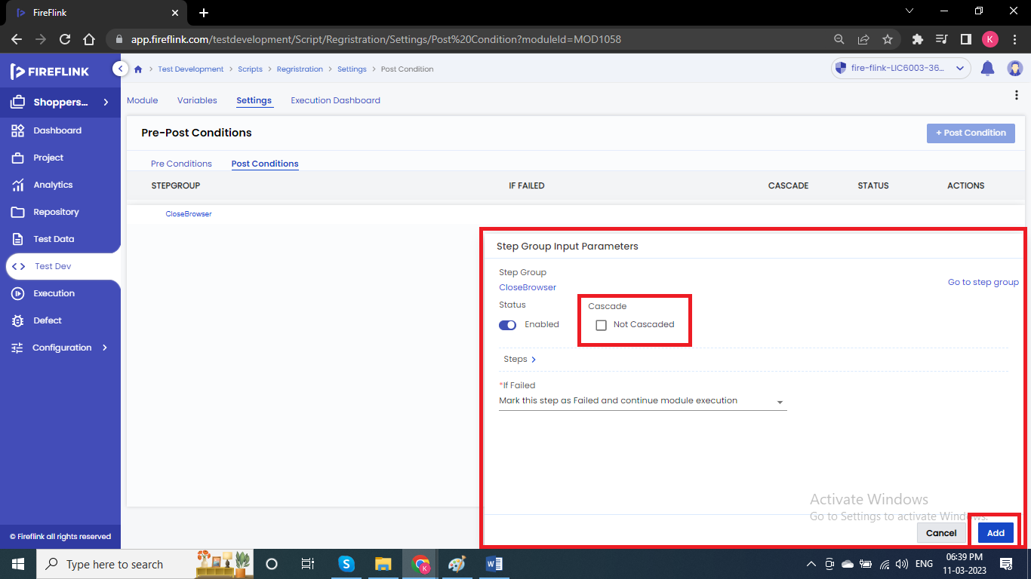

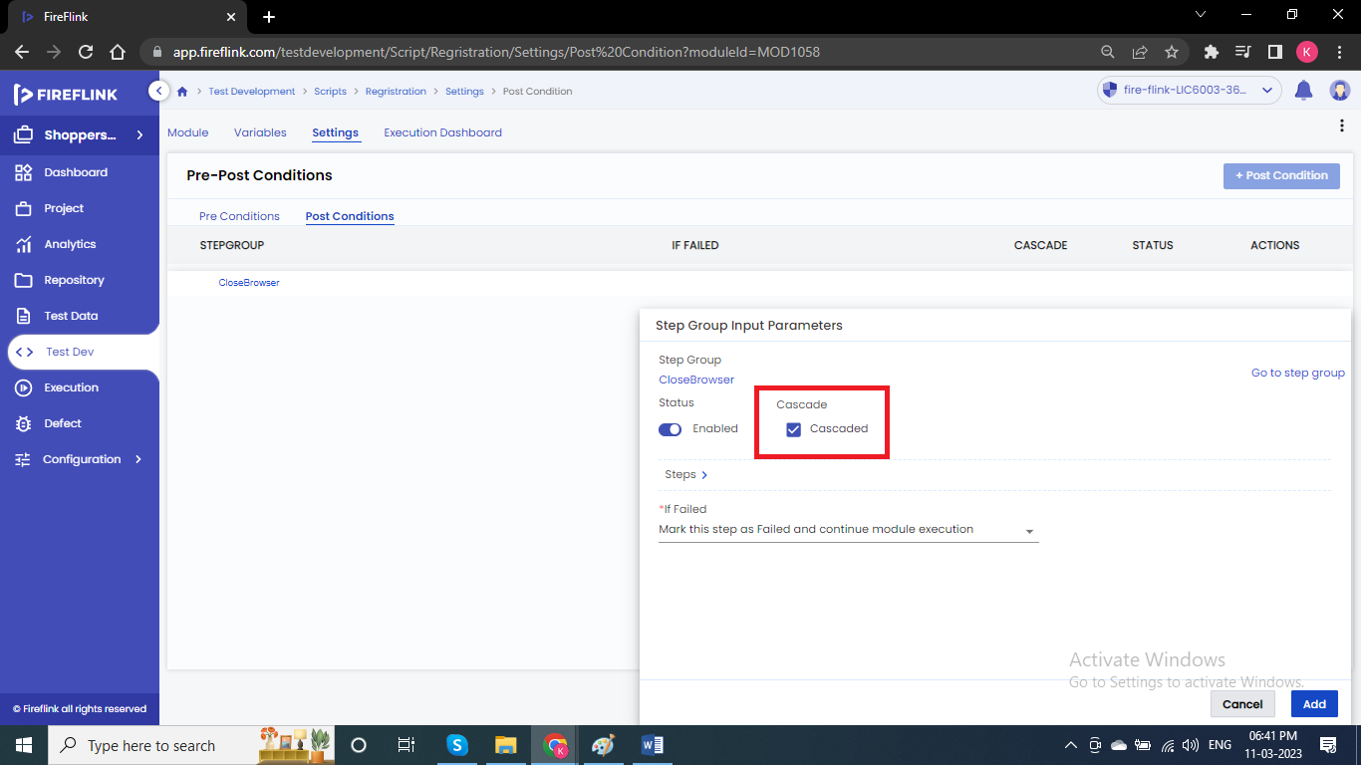

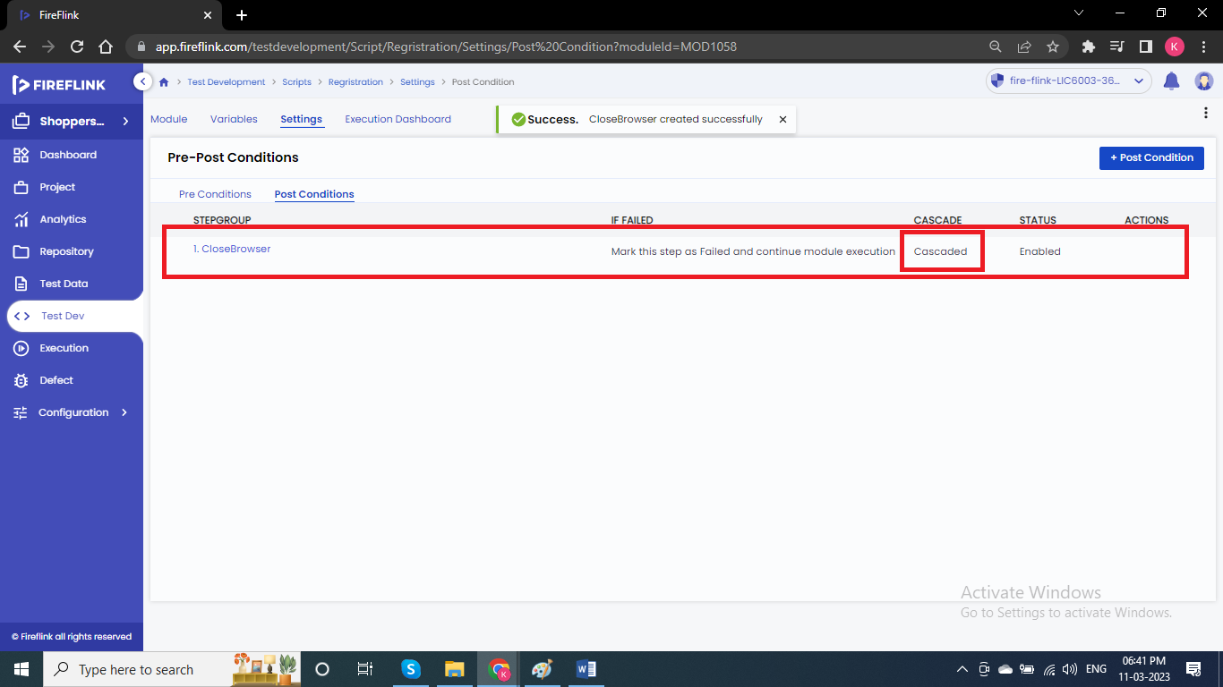

**Note:** In Module level, we have option called Cascade (Post-condition added in module level will be applicable for all the test scripts added under that module).